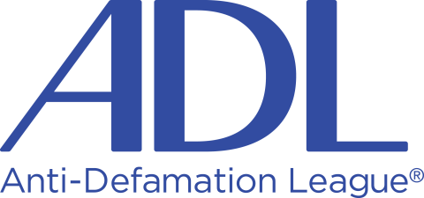
JOIN THE CONVERSATION!
ADL SUPREME COURT REVIEW 2017
THURSDAY, JULY 6, 2017 * 9:30-11:30 AM
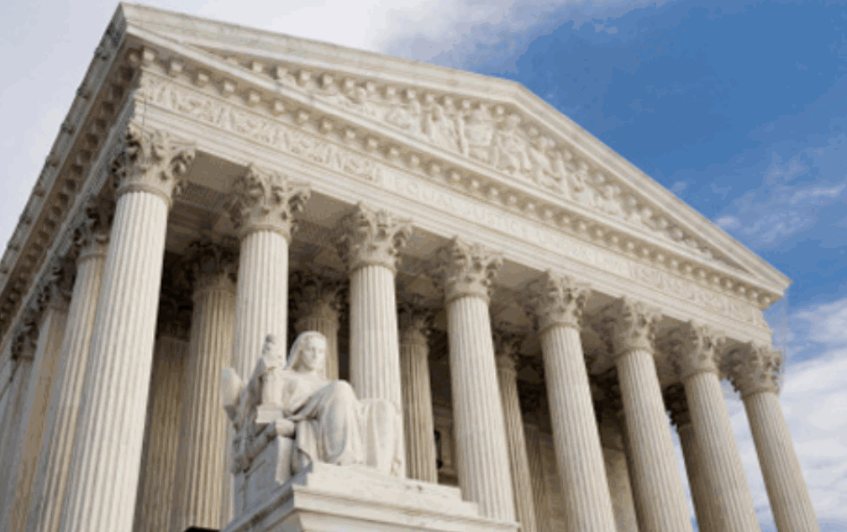
Mountain States Anti-Defamation League Conference Center
1120 Lincoln Street, Suite 1301, Denver CO 80203
A light breakfast is included. The program and breakfast are provided free of charge.
https://www.adl.org/supreme-court-review-2017
With a new justice on the Supreme Court and dozens of legal challenges to the President’s executive orders filed all over the country, this year has already been a blockbuster one for the courts. Watch distinguished legal scholars Erwin Chemerinsky, Frederick Lawrence, and Dahlia Lithwick as they discuss how Neil Gorsuch could impact the future of Supreme Court jurisprudence, the most important cases of the term—on topics such as separation of church and state, racial bias in the criminal justice system, and free speech—and challenges to the President’s executive orders.
This event is presented by the Anti-Defamation League and the National Constitution Center.
RSVP by calling 303-830-2460 or via email to iaboaf@adl.org by June 30.
If you cannot attend our screening, join the program from any computer at 10 am Mountain Time on July 6 at https://www.adl.org/supreme-court-review-2017
Colorado attorneys who wish can earn 2 general CLE credits for attending. The fee for CLE credits is $36.

