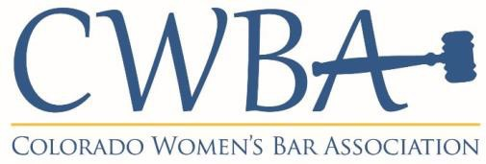

Mentorship Committee Meeting Agenda
Tuesday, July 12, 2022
Via Zoom

Agenda Items

- 5 Minutes Call to Order, Welcome, & Introductions

- 25 minutes Rockstar Event: Tues., August 30, 2022 at 5:30pm!
- Rockstars are:
  - Judge Adam Espinosa
  - Catherine Shea
  - Cristal DeHerrera
  - Miranda Hawkins
- Continue to brainstorm questions (see separate doc w/ questions from last year)

- 5 minutes 2022 Mentor/Mentee class summer meet-ups

- 10-15 minutes Law Student Engagement / Support – 2022-2023
      - Last meeting discussed hosting a mid-day / lunch session at DU and CU, going to work with the career services to set-up
        - Heidi was going to email Eric Bono
        - Danielle going to talk to Todd Rogers
      - Potential dates? Sept / Oct
      - Identify point person for DU / CU

- 10-15 minutes Polsinelli (Jennifer Evans) – host offer
      - November? In person 2023 application kick-off event? Final 2022 meet-up?

- 5 Minutes Questions, Concerns, Closing, Thank you!

Next Meeting
August 9, 2022 at 5:30pm

CWBA Mentorship Committee Contacts
Co-Chair: Karin Williamson kwilliamson@childsmccune.com
Co-Chair: Whitney Travis Kelly whitney.traviskelly@cardinalfinancial.com

